:травы:Mighty Beet — детальніше заглибся в практику.

1. В Google docs створи 5 тест-кейсів для функціонального тестування сайту <https://automoto.ua/uk/> (5 найбільш пріоритетних тестів). *Посилання на документ додай до ЛМС.*

| **Test Case ID** | | 0001 | **Test Case Description** | | Test the registration functionality on website | | | |
| --- | --- | --- | --- | --- | --- | --- | --- | --- |
| **Created By** | | Anastasiia Luzina | **Reviewed By** | | Vasyl Suberliak | | **Version** |  |
|  | | | | | | | | |
| **Tester's Name** | | Anastasiia Luzina | **Date Tested** | | 20/04/2023 | | **Test Case (Pass/Fail/Not Executed)** | **Pass** |
|  | | | | | | | |  |
| **S #** | **Prerequisites:** | | |  | **S #** | **Test Data** | | |
| 1 | Navigate to https://automoto.ua/uk// | | | 1 | phone number = 380999999999 | | |
| 2 |  | | | 2 |  | | |
| 3 |  | | | 3 |  | | |
| 4 |  | | | 4 |  | | |
|  | | | | | | | | |
| **Test Scenario** | Verify on entering valid data , the user can register on the website | | | | | | | |
|  | | | | | | | | |
| **Step #** | **Step Details** | | | | **Expected Results** | | | **Pass / Fail / Not executed / Suspended** |
|
| 1 | Сlick the icon “Реєстрація” | | | | The registration window is opened | | | Pass |
| 2 | Enter a valid phone number | | | | The phone number is displayed on the screen | | | Pass |
| 3 | Press the button “Продовжити” | | | | A new user must be successfully registered | | | Pass |

| **Test Case ID** | | 0002 | **Test Case Description** | | Test the car ordering function | | | |
| --- | --- | --- | --- | --- | --- | --- | --- | --- |
| **Created By** | | Anastasiia Luzina | **Reviewed By** | | Vasyl Suberliak | | **Version** |  |
|  | | | | | | | | |
| **Tester's Name** | | Anastasiia Luzina | **Date Tested** | | 20/04/2023 | | **Test Case (Pass/Fail/Not Executed)** | **Pass** |
|  | | | | | | | |  |
| **S #** | **Prerequisites:** | | |  | **S #** | **Test Data** | | |
| 1 | Navigate to https://automoto.ua/uk// | | | 1 | phone number = 380999999999 | | |
| 2 |  | | | 2 |  | | |
| 3 |  | | | 3 |  | | |
| 4 |  | | | 4 |  | | |
|  | | | | | | | | |
| **Test Scenario** | Verify on entering valid data , the user can send a request for car selection | | | | | | | |
|  | | | | | | | | |
| **Step #** | **Step Details** | | | | **Expected Results** | | | **Pass / Fail / Not executed / Suspended** |
|
| 1 | At the header of the site, click the button ”Замовити” | | | | The order form is displayed on the screen | | | Pass |
| 2 | In the checkbox, select the option “Вживане авто з європи” | | | | The box is checked | | | Pass |
| 3 | Enter a valid phone number | | | | The phone number is displayed on the screen | | | Pass |
| 4 | Press the button “Надіслати заявку” | | | | Form submitted successfully | | | Pass |

| **Test Case ID** | | 0003 | **Test Case Description** | | test the operation of the filters | | | |
| --- | --- | --- | --- | --- | --- | --- | --- | --- |
| **Created By** | | Anastasiia Luzina | **Reviewed By** | | Vasyl Suberliak | | **Version** |  |
|  | | | | | | | | |
| **Tester's Name** | | Anastasiia Luzina | **Date Tested** | | 20/04/2023 | | **Test Case (Pass/Fail/Not Executed)** | **Pass** |
|  | | | | | | | |  |
| **S #** | **Prerequisites:** | | |  | **S #** | **Test Data** | | |
| 1 | Navigate to https://automoto.ua/uk// | | | 1 |  | | |
| 2 |  | | | 2 |  | | |
| 3 |  | | | 3 |  | | |
| 4 |  | | | 4 |  | | |
|  | | | | | | | | |
| **Test Scenario** | Check that the filters are working according to specifications | | | | | | | |
|  | | | | | | | | |
| **Step #** | **Step Details** | | | | **Expected Results** | | | **Pass / Fail / Not executed / Suspended** |
|
| 1 | In the filters form, select the option “Б/у” | | | | The filter is highlighted in orange | | | Pass |
| 2 | Select "Легкові" from the "тип" drop-down list | | | | The filter is displayed in the form | | | Pass |
| 3 | Select "BMW" from the "марка" drop-down list | | | | The filter is displayed in the form | | | Pass |
| 4 | Select "3 Series" from the "Модель" drop-down list | | | | The filter is displayed in the form | | | Pass |
| 5 | Press the button “Пошук” | | | | The page with cars selected by filters is displayed | | | Pass |

| **Test Case ID** | | 0004 | **Test Case Description** | | Test the ability to get the seller's contact details | | | |
| --- | --- | --- | --- | --- | --- | --- | --- | --- |
| **Created By** | | Anastasiia Luzina | **Reviewed By** | | Vasyl Suberliak | | **Version** |  |
|  | | | | | | | | |
| **Tester's Name** | | Anastasiia Luzina | **Date Tested** | | 20/04/2023 | | **Test Case (Pass/Fail/Not Executed)** | **Pass** |
|  | | | | | | | |  |
| **S #** | **Prerequisites:** | | |  | **S #** | **Test Data** | | |
| 1 | Navigate to https://automoto.ua/uk// | | | 1 |  | | |
| 2 |  | | | 2 |  | | |
| 3 |  | | | 3 |  | | |
| 4 |  | | | 4 |  | | |
|  | | | | | | | | |
| **Test Scenario** | Check that the user has the ability to view the seller's contacts after clicking on the corresponding button | | | | | | | |
|  | | | | | | | | |
| **Step #** | **Step Details** | | | | **Expected Results** | | | **Pass / Fail / Not executed / Suspended** |
|
| 1 | Open information about the first car by clicking on the post | | | | The post is displayed on the screen | | | Pass |
| 2 | On the right, press the button “Контакти продавця” | | | | The seller's contact page is displayed | | | Pass |

| **Test Case ID** | | 0005 | **Test Case Description** | | Test the function arranging instalments for the purchase | | | |
| --- | --- | --- | --- | --- | --- | --- | --- | --- |
| **Created By** | | Anastasiia Luzina | **Reviewed By** | | Vasyl Suberliak | | **Version** |  |
|  | | | | | | | | |
| **Tester's Name** | | Anastasiia Luzina | **Date Tested** | | 20/04/2023 | | **Test Case (Pass/Fail/Not Executed)** | **Pass** |
|  | | | | | | | |  |
| **S #** | **Prerequisites:** | | |  | **S #** | **Test Data** | | |
| 1 | Navigate to https://automoto.ua/uk// | | | 1 | Name = Анастасія | | |
| 2 |  | | | 2 | phone number = 380 99 999 99 99 | | |
| 3 |  | | | 3 |  | | |
| 4 |  | | | 4 |  | | |
|  | | | | | | | | |
| **Test Scenario** | Verify that after entering valid data, the user can apply for a car instalment plan | | | | | | | |
|  | | | | | | | | |
| **Step #** | **Step Details** | | | | **Expected Results** | | | **Pass / Fail / Not executed / Suspended** |
|
| 1 | Open information about the first car by clicking on the post | | | | The post is displayed on the screen | | | Pass |
| 2 | On the right, press the button “Купити в розстрочку” | | | | The application form is open on the screen | | | Pass |
| 3 | Enter a valid name and phone number | | | | Name and phone number are displayed on the screen | | | Pass |
| 4 | Press the button “Залишити заявку” | | | | Form submitted successfully | | | Pass |

2. За допомогою <https://reqbin.com/> протестуйнаступні методи API [Reqres](https://reqres.in/):

* LIST USERS

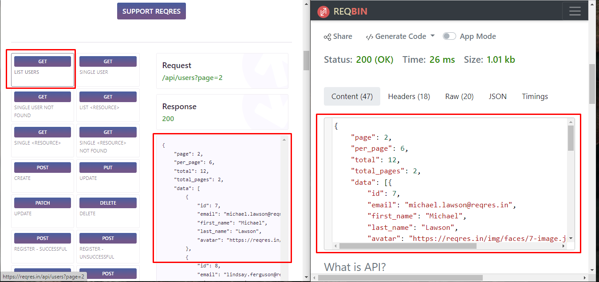

* SINGLE USER

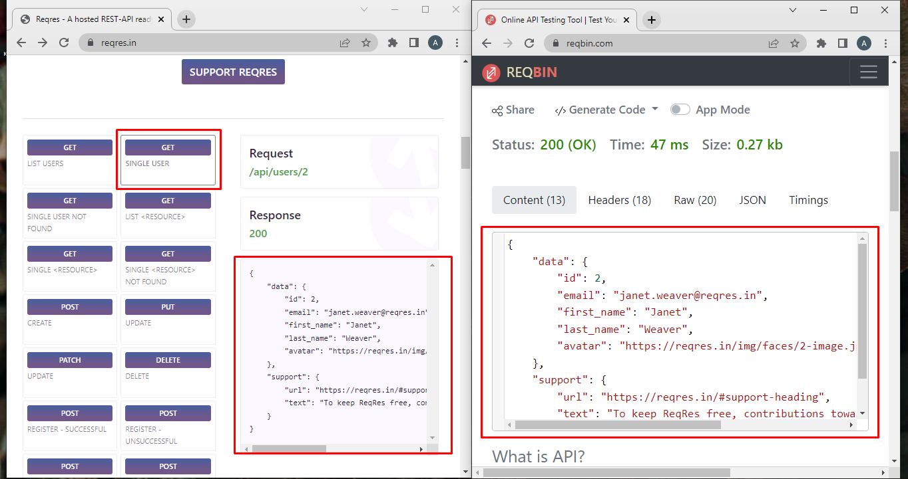

* CREATE

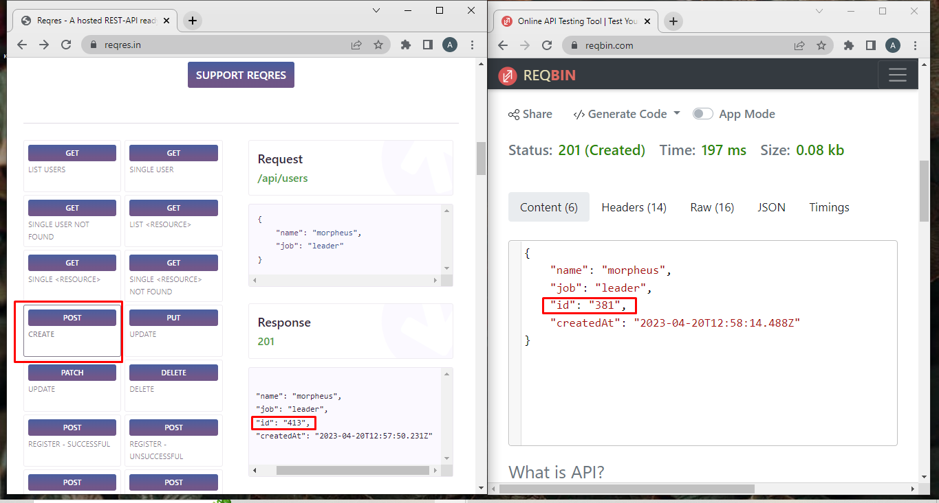

* UPDATE (PUT)

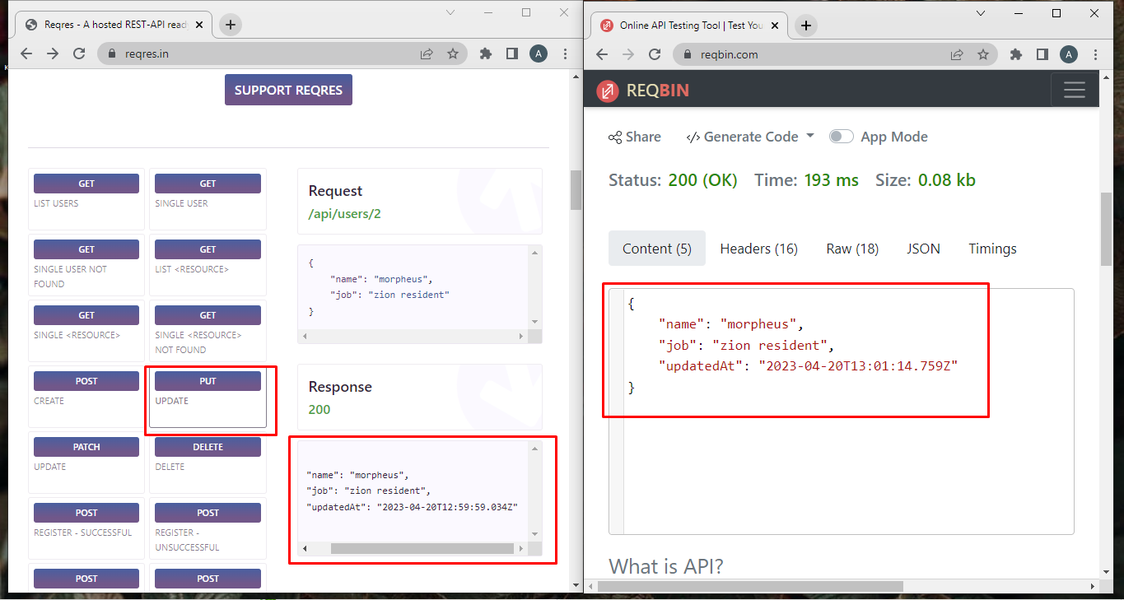

* UPDATE (PATCH)

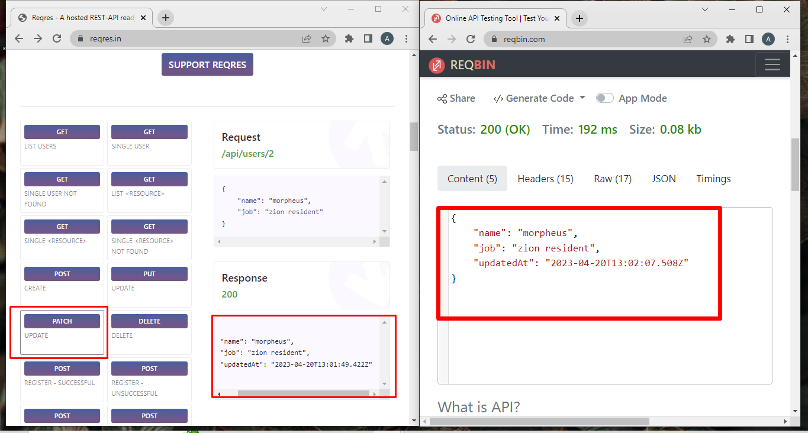

* DELETE

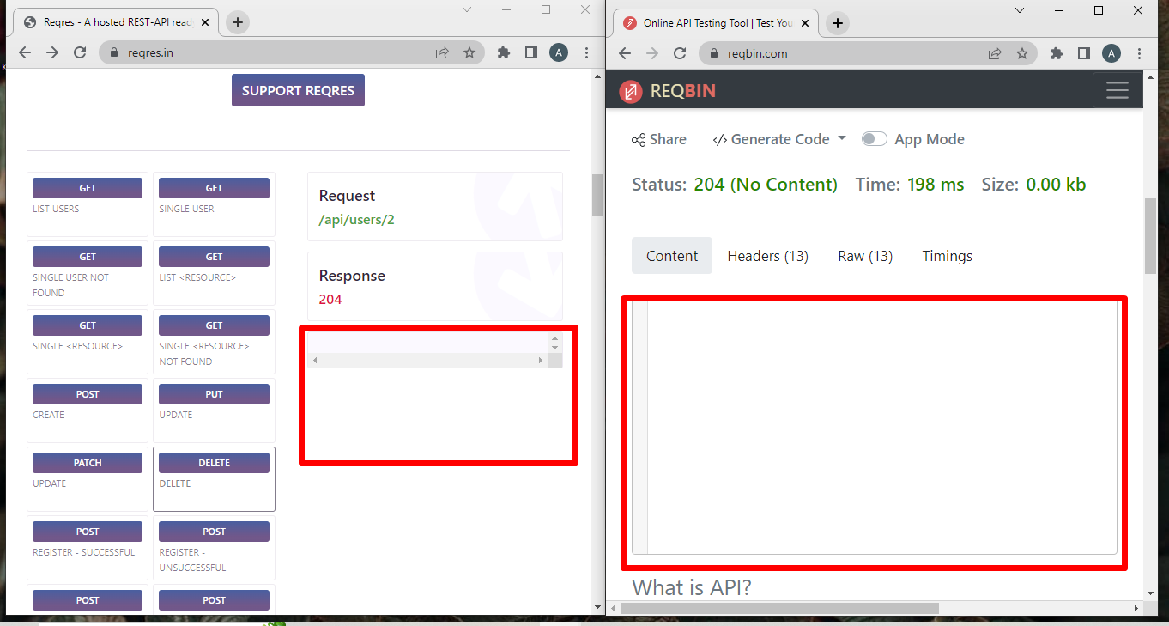

* REGISTER - SUCCESSFUL

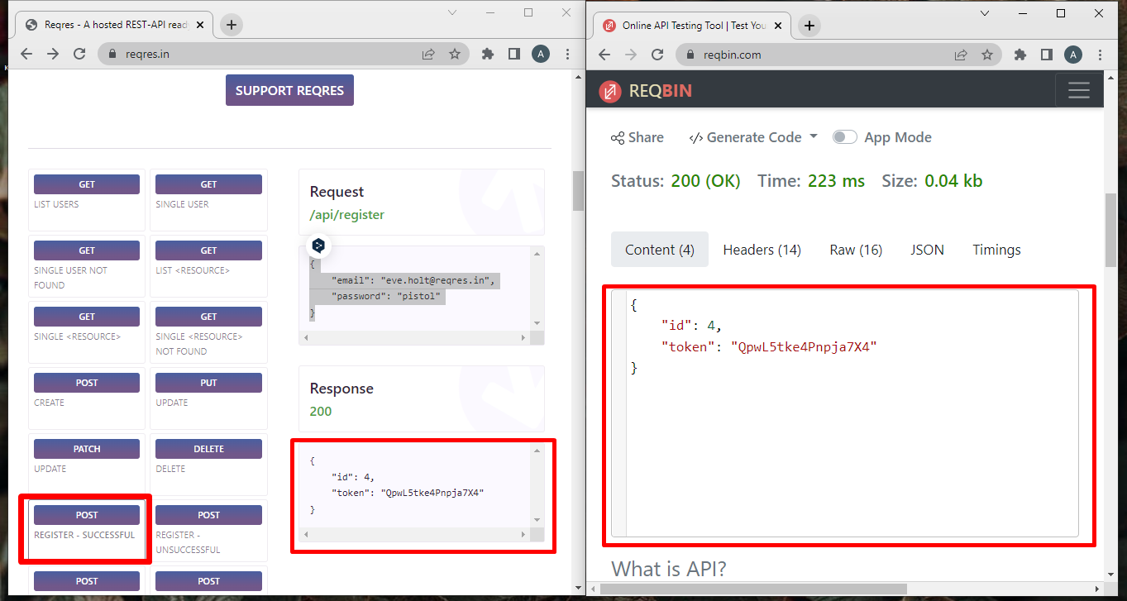

* LOGIN - SUCCESSFUL

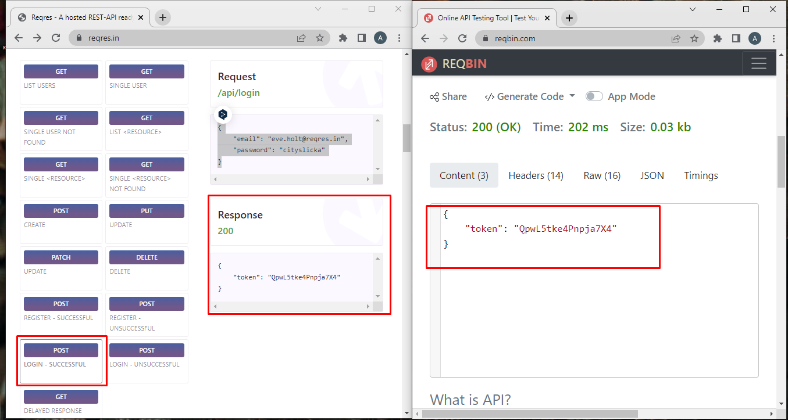

Створи документ, в якому у довільному форматі, але зі скриншотами, опиши знайдені баги. Документ додай до LMS.

:лиственное_дерево:Mighty Beet — різнобічно опануй тематику уроку.

| 1. Виконай завдання попереднього рівня;  2. Використовуючи <https://reqbin.com/>, відправ по одному валідному запиту для кожного методу в [GO REST](https://gorest.co.in/) (**/users** endpoint).  На сайті <https://reqbin.com/> - не відтворюються методи POST, PUT, PATCH,DELETE навіть при наявному токені, лише GET    Всі інші запити відтворила на самому ж сайті [GO REST](https://gorest.co.in/)          2.1. За відправки кожного запиту порівняй його деталі, введені у <https://reqbin.com/> і відображені в Developer Tools. |
| --- |